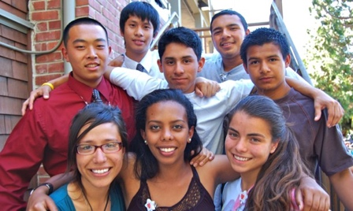

***Creating greater equity in higher education for low-income students***

Dr. Marilyn A. Winkleby, President and CEO <http://accesstoachievement.org/>

**We are pleased to provide a summary of our activities for 2019 - 2022**

**We continued our existing support of students in the Bay Area who lack educational support and are excited to focus this report on our new partnerships with rural high schools.**

In 2019 *Access to Achievement Education Foundation* began partnering with rural high schools to learn more about the needs of college-bound students, build trust with teachers and counselors, and create opportunities for future collaborations. High schools in the small rural towns in California’s Central Valley often experience a lack of resources, high dropout rates and low college attendance. This environment creates barriers for students dedicated to higher education. Furthermore, although these students are typically high school leaders and 4.0 students, they often lack funds for college expenses. Once in college they may question whether they belong and struggle to compete academically with students from high resourced families and schools.

In 2019 we formed a partnership with Riverdale, a small town of 3,000 residents, 70% Latino, and 25 miles south of Fresno. One student described Riverdale as “the town where you look out and see only dirt, cows, and corn; where the Dollar Store is a main attraction; and there is no close hospital.” Too few students continued on to 4-year universities, and almost all students lacked a computer, with many completing their homework on their cell phones.

**Riverdale High School Medical Club**

Eduardo Gonzalez, a graduate of our 2019 Stanford Medical Youth Science Program, returned to Riverdale as a junior in high school and began the Riverdale Medical Club. Mr. Chavira, a biology teacher and graduate of Riverdale High became the club advisor. When Covid arrived, all classes were on zoom, and this allowed us to “meet” with students, teachers, and counselors. We hosted speakers from universities; developed college guidance resources; gave presentations on types of colleges, financial aid and scholarships; edited UC statements; and conducted mock interviews for scholarships. We promised any student admitted to college who had no computer a free laptop. We also supported students as they became advocates for their communities regarding needs for clean water and mental health resources. Students in college returned to tell their stories about college including one who is training to become a pediatric neonatal nurse at UCLA.

**Medical Club Expands to New Career Paths**

As members of the Medical Club saw the need to expand to include students interested in non-medical careers, they created college resources about other careers including those in agriculture, law, education, engineering, technology, and science.

**Riverdale Goes to College**

There are approximately 100 students in each graduating class and students are becoming more successful in being accepted to college. Some have been accepted to nursing schools and top universities, winning full scholarships. Others have chosen to enroll in community colleges and transfer after two years. In 2021 twenty student were admitted to college and were awarded a free laptop from Access to Achievement; in 2022 twenty-four students received laptops. A summary of their success is below.

Where are they now?

* + UCLA
  + UC Berkeley

Majors

* + Biology
  + Neurobiology, Physiology, and Behavior
  + Public Health
  + Sociology
  + Architecture
  + Criminology and Political Science
  + Journalism
  + Latinx Studies
  + UC Davis
  + UC Merced
  + Simpson University Nursing School
  + CSU, Fullerton Nursing School
  + CSU, Fresno
  + CSU, Stanislaus
  + West Hills College Lemoore
  + Studying abroad in Spain (part of UC Berkeley)

Scholarship Awards:

* + Regents’ and Chancellor’s Scholarship
  + The Gates Scholarship
  + Smittcamp Family Honors College
  + The Riverdale Foundation Student Scholarships
  + And many more!

The 24 college bound Riverdale seniors who Brainstorming meeting with AVID and medical

won the Access to Achievement Scholarships, club teachers, the school counselor, and several

$1,000 for a laptop computer, Spring 2022 Ambassador Club members, Summer 2022

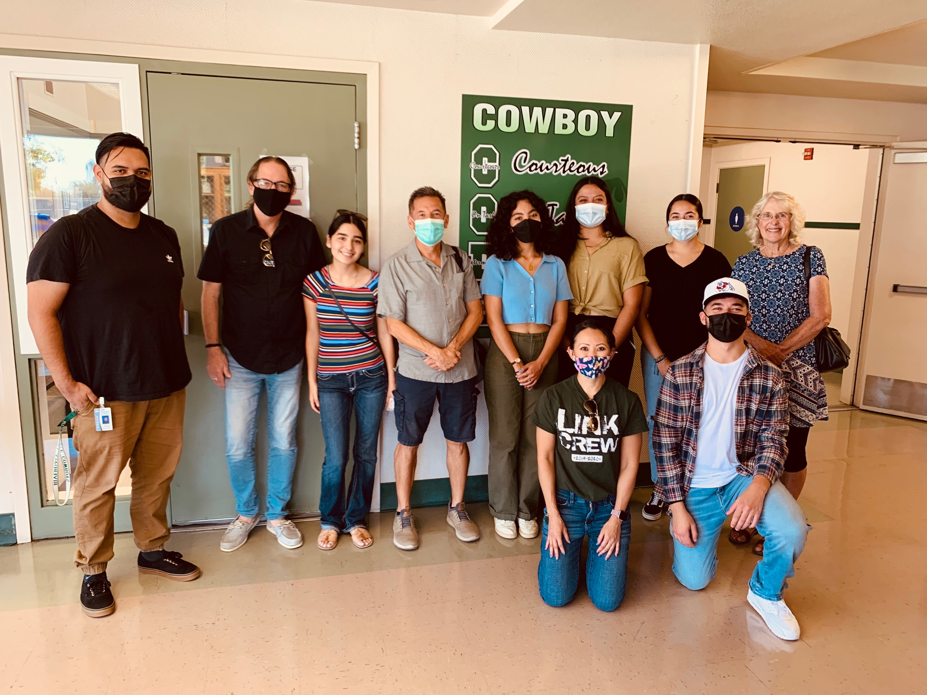

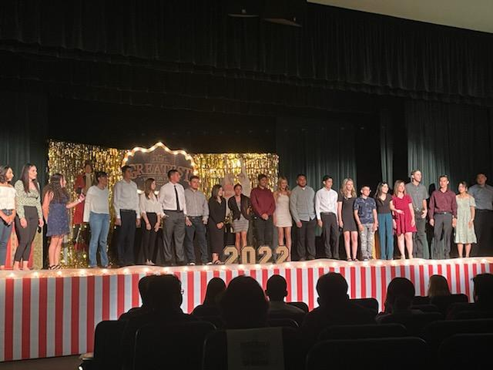

**Graduates form the Ambassador’s Club**

There is an active Ambassadors Club of past graduates now in college who mentor the Riverdale High School students. They collaborate with two non-profits in the Central Valley where local students who are now in college mentor younger students and provide culturally tailored college readiness materials—Mi Mentor and Central Valley Scholars.

**Students become Community Advocates**

We have focused on preparing students for college as well as supporting them to become advocates for their communities. Members of the Ambassador Club: 1) delivered a powerful presentation about recent college successes to the Riverdale School Board; 2) traveled to Sacramento to meet with lawmakers to advocate for two clean water bills; 3) helped create and present workshops to Riverdale parents on the college admissions process; and 4) participated in community service projects with UCSF Fresno Health Youth Corps and others.

School Board presentation: In Riverdale the School Board acts somewhat like a City Council and has only one Latino member. The Ambassador Club wanted the School Board to be fully aware of the recent success of students going to college. They created and delivered an impressive PowerPoint presentation titled “College Comes to Riverdale”. They are planning a college outreach day where middle and high school students and their parents come to Riverdale High for workshops on preparing for college, college admissions, and financial aid.

Clean water bills advocacy: Rosa Espinosa who is in nursing school and Eduardo Gonzalez who attends Fresno State Honor’s College, both of whom graduated from Riverdale High, traveled to Sacramento on August 2022 to meet with lawmakers to advocate for two clean water bills. In Central California’s rural communities there is contaminated water for many reasons, including dairies that have manure and fertilizer runoff that pollute the water. Families who don’t have clean water have to buy bottled water and pay for tanks of water outside their homes. The two clean water bills passed--SB222 creates a fund for low-income Californians to pay off their drinking water bills and AB2201 limits new groundwater wells from being too close to existing domestic wells and dewatering or contaminating them. One student who went to Sacramento wrote, “I had never been in an elevator or seen a skyscraper.”

Rosa Espinoza, nursing school student and Riverdale graduate,

at the podium testifying for clean water at the State Capital

**Parent Workshops**

Many parents in Riverdale have little knowledge of college and professional careers. Some are disabled from years of working in the fields and have occupational injuries, others may question the value of college. Students are often encouraged to work after high school to help with family finances. The popular evening parent college workshops in Spanish offer parents the chance to learn and ask questions about the advantages of colleges, costs, and future careers.

Eduardo Gonzalez, Fresno State Honor’s College student and Riverdale graduate,

presents at one of the Spanish language parent workshops

**Expanding to Other Rural High Schools**

We plan to expand to schools beyond Riverdale, to share resources that have been developed and reach more students attending schools where few students successfully transition to college. Although there are a number of schools in the same geographic area as Riverdale High School, few if any collaborations now exist.

We will continue our emphasis on health careers, college admissions, and collaborations with teachers and counselors. Given the large number of students who drop out or do not attend college, we plan to explore student interest in non-academic careers that require fewer years of training but lead to well-paying jobs and meaningful careers (e.g., dairy management, allied health careers, cosmetology, teacher aides, construction).